Lesson 3 Demo 4: Building a Maven Project

This section will guide you to:

* Build a Maven project in Jenkins

This lab has four sub-sections, namely:

1. Configuring git on Jenkins
2. Forking a sample repository
3. Creating a Jenkins build job to build a Maven project
4. Building the Maven project

**Step 1:** Configuring git on Jenkins.

* Go to ***Manage Jenkins*** from the Jenkins dashboard and select ***Global Tool Configuration****.*
* Scroll down to the ***Git*** section and click on ***Add git***.

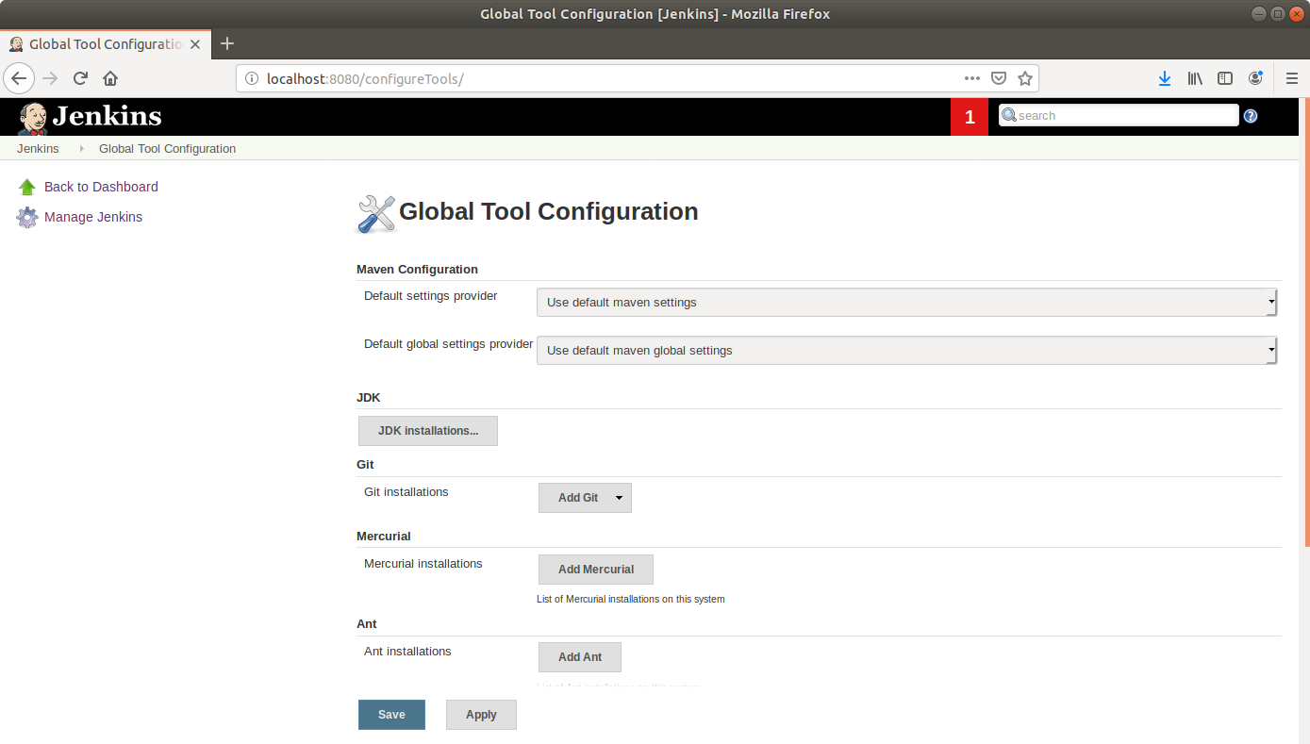

* Enter a **name** to refer to the git installation.
* Enter the path to git at the *Path to git executable field (****/usr/bin/git****)* and click Save.

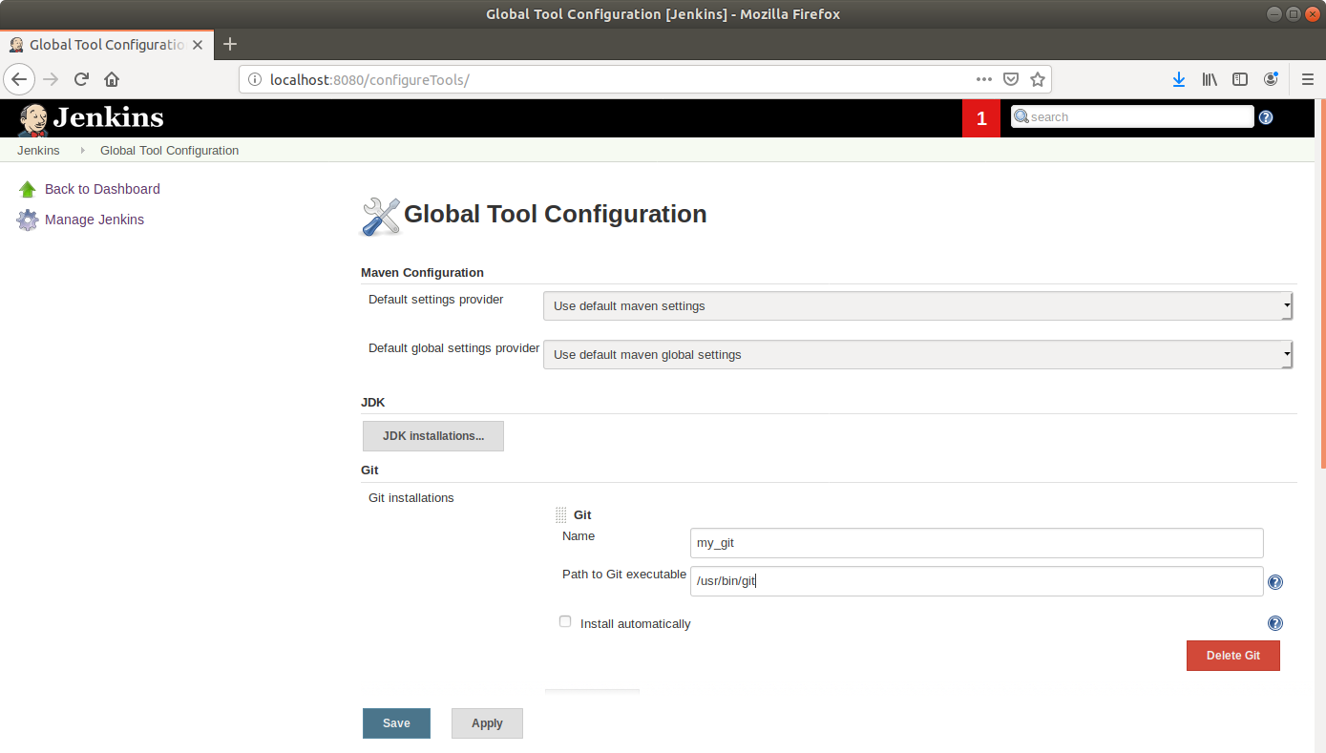

**Step 2:** Forking a sample repository

* **Login** to your Github account.
* Navigate to <https://github.com/jenkins-docs/simple-java-maven-app> and click on ***Fork***.

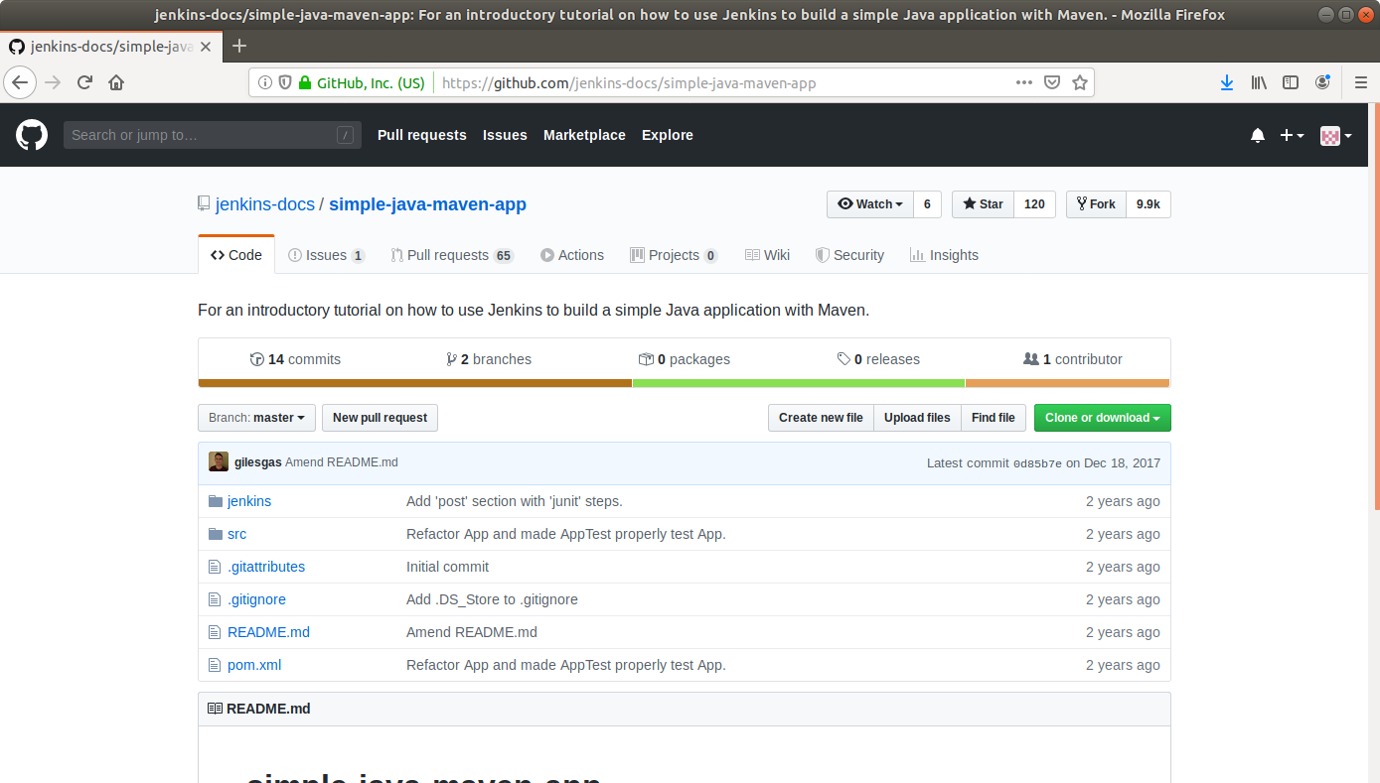

* Open the terminal.
* Run ***git clone [Forked_REPO URL]*** to clone the repo locally.

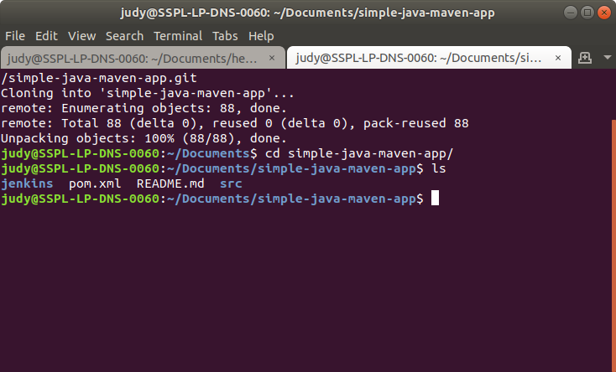

**Step 3:** Creating a Jenkins build job to build a Maven project

* Select ***Maven Project*** as the build job type.

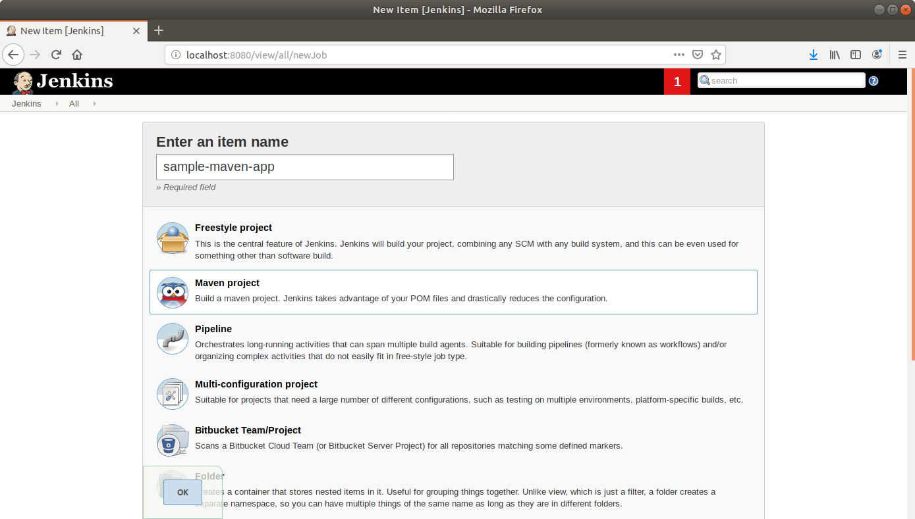

* Click ***OK***.
* Leave the defaults as they are and scroll down to the ***Source Code Management*** section.
* Select ***Git***.
* Enter the local path to the app directory in the Repository URL field.

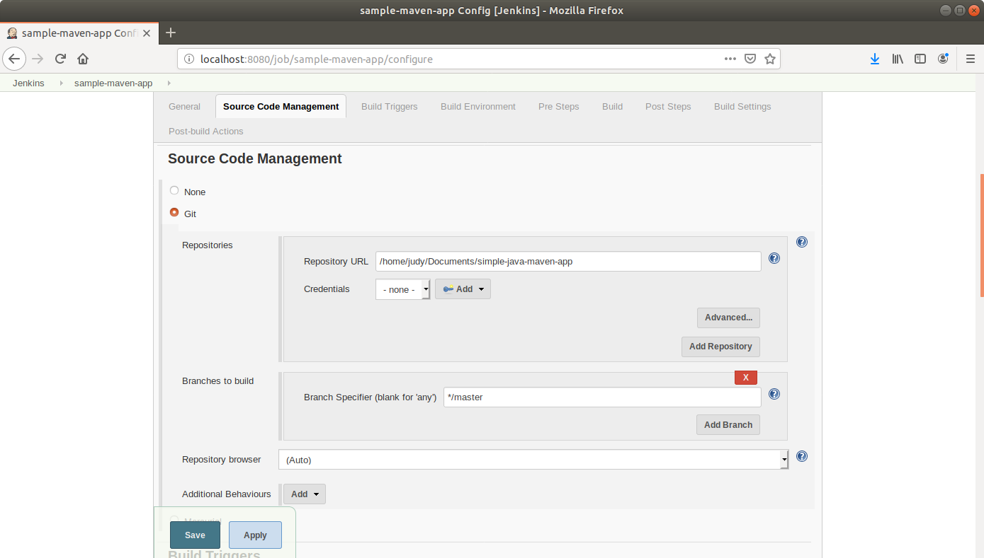

* Click ***Save***.

**Step 4:** Building the Maven project

* Click on the project name in the Jenkins **dashboard**.
* Click ***Build Now*** in the project window. Jenkins will now build your project.

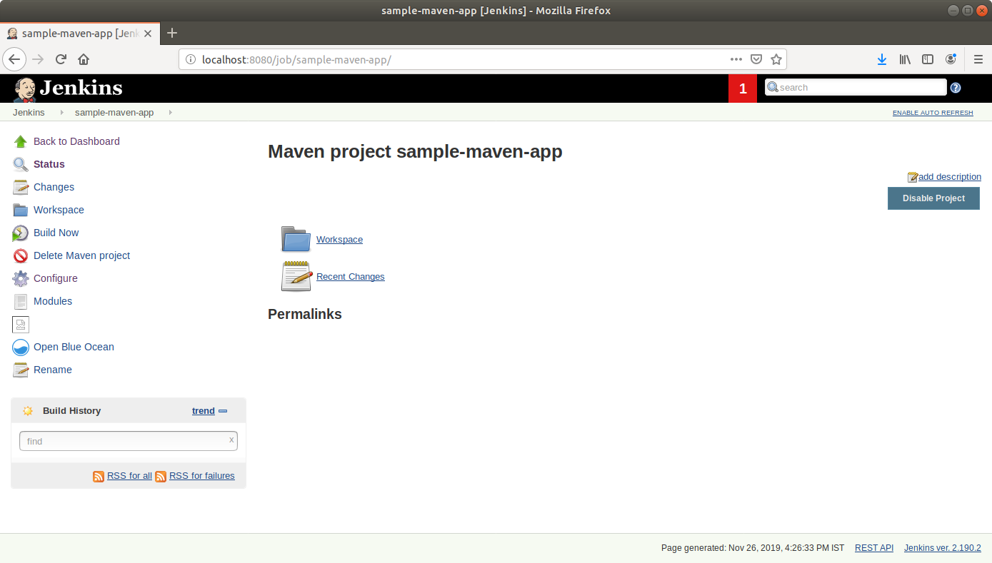

* Click on the ***Build History***to view the build results.
* Click on the ***Console Output*** to view the build logs.

